**Week 4**

5. JWT-hands-on

**Create authentication service that returns JWT**

com.cognizant.spring_learn.config

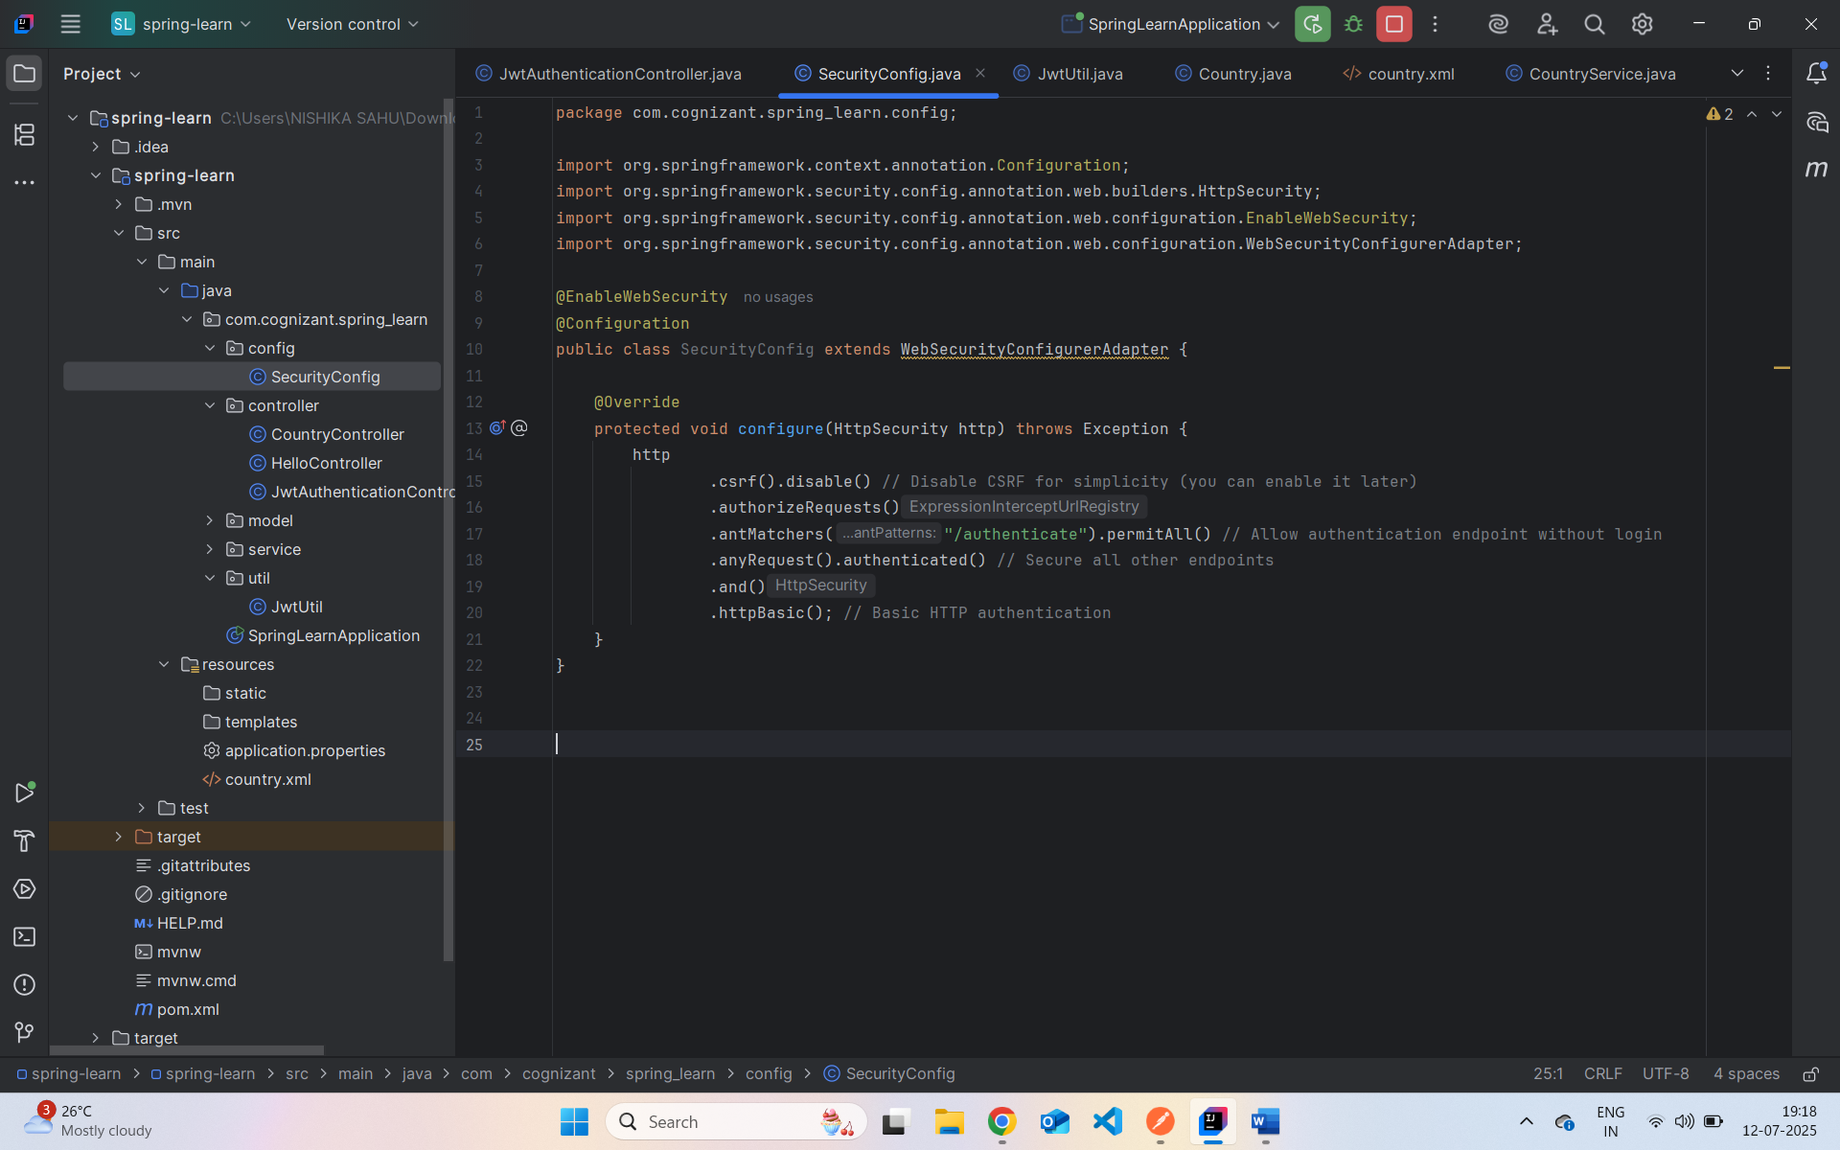

com.cognizant.spring_learn.controller

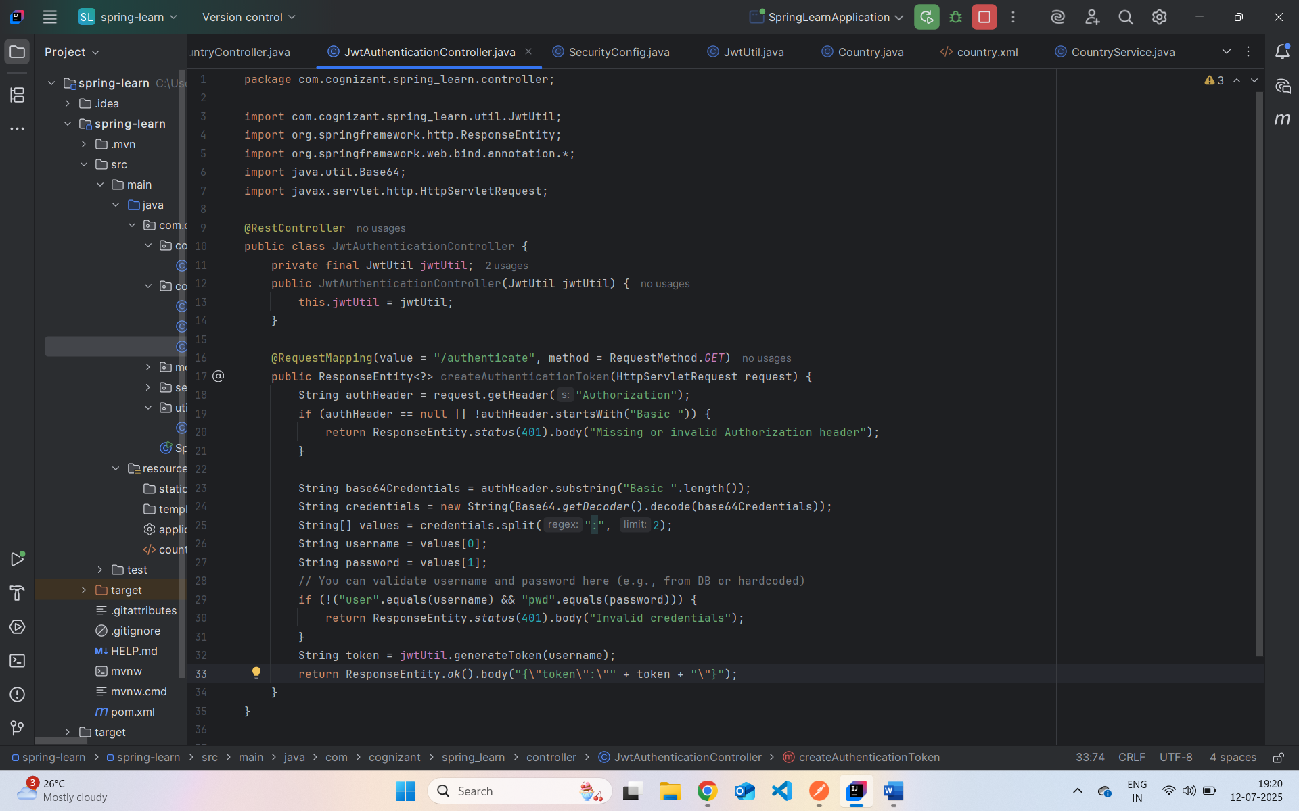

com.cognizant.spring_learn.util

Application.properties

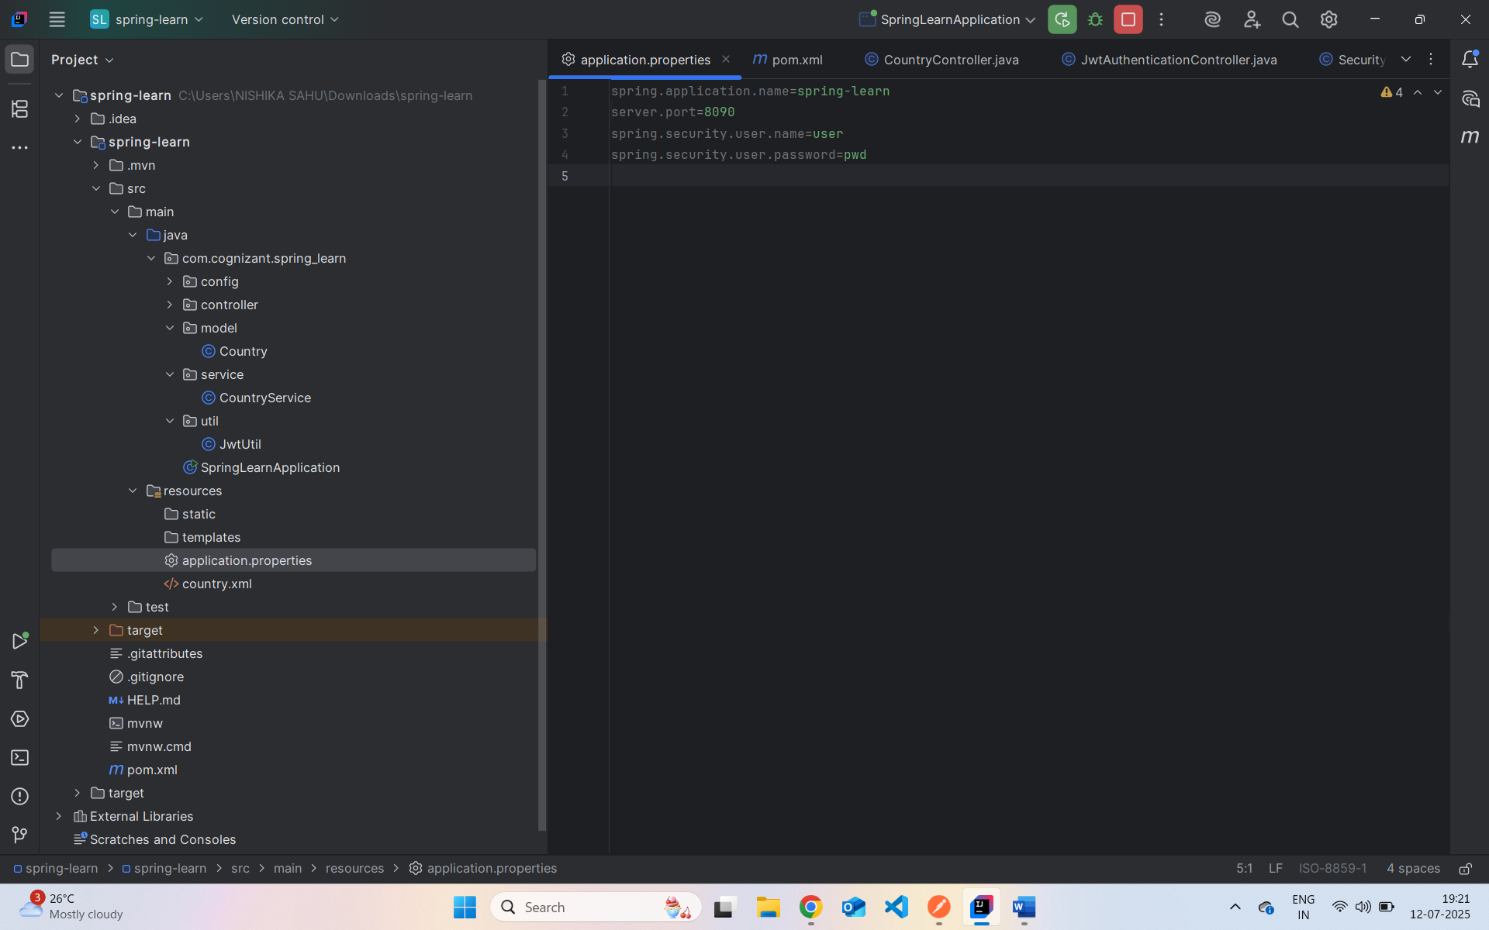

Output In PostMan:

